Project Plan

Project software Engineering

Project : Weather Station

Company: Sunny days

Group: 6

Authors:

Angel Atanasov - 476057  
Alexandra Melei  
Dan Bouwman  
Isaija Sitdikov  
Maksym Dryhval

Version 0.1

Saxion Enschede

Life Science, Engineering & Design

International Project Week

Postbus 70.000

7500 KB Enschede

(053) 4871111

www.saxion.nl

# Table of contents

**Table of contents** **1**

**1.Assignment** **2**

**1.1. Clients** **2**

**2.Project Organisation** **3**

**3.Requirements** **4**

**4****.Methodology** **5**

**5****.Risk Analysis** **6**

**6****.Definition of Done** **7**

**7****.Tool usage** **8**

# 

# 

# 1.Assignment

The goal of this assignment is to create software that will collect data from a weather station and display it in a GUI. There are already some weather stations running in the local network. But it lacks a front-end for the user to view the information.

The sensors are connected to The Things Network. This is a network of connected smart devices to share sensor data all over the world. A local client needs to be created, which retrieves data from our database.

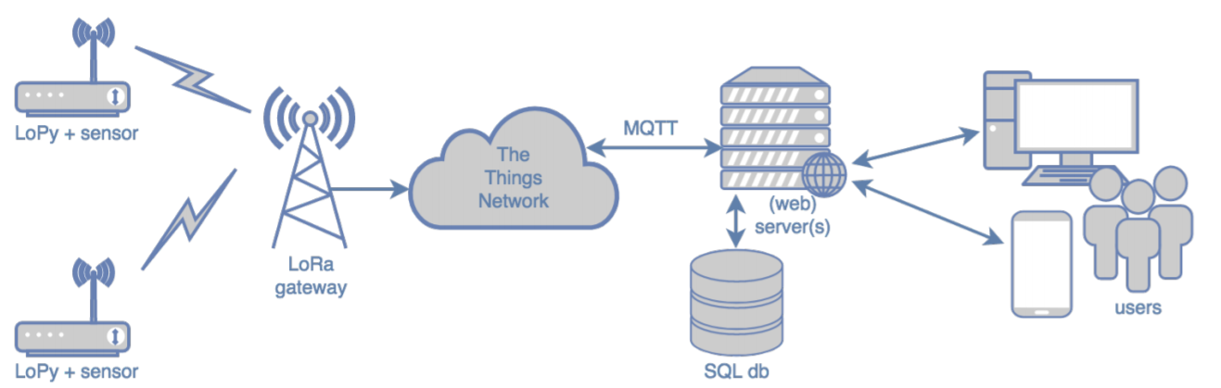

## 1.1. Clients

|  |  |  |  |  |
| --- | --- | --- | --- | --- |
| **Name** | **E-mail** | **Additional information** | **Office location** | **Office Hours** |
| Christiaen Slot | c.g.m.slot@saxion.nl |  | W2.32 | Monday, Tuesday, Thursday, and Friday |
| Ronald Tangelder | r.j.w.t.tangelder@saxion.nl | Work Phone 088 019 6347 | W2.32 | Monday to Friday |

# 2.Project Organisation

|  |  |  |  |  |  |
| --- | --- | --- | --- | --- | --- |
| **Surname** | **Name** | **Initials** | **Class** | **Student. ID** | **Occupation** |
| Angel | Atanasov | A.A. | ETI2V.IB | 476057 | Plant |
| Alexandra | Melei | A.M. | ETI2V.IB | 479787 | Complete finisher |
| Daan | Bouwman | D.B. | ETI2V.B | 472857 | Implementer |
| Isaija | Sitdikov | I.S. | ETI2V.B | 469705 | Coordinator |
| Maksym | Dryhval | M.D. | ETI2V.IB | 483576 | Specialist |

To make a successful project, a team needs to be divided into specific roles.

Based on the **Belbin** roles, our team decided the specific tasks of everyone. There has been a discussion deciding who would be best for each role. Every member started by telling their Belbin test results and how accurate they thought it was. We have also discussed our strong points during previous projects that we have been part of, and thus we concluded these roles in the team:

**Isaija : Coordinator**

Isaija is going to be the Coordinator, this being his highest point based on the Belbin test.

**Daan: Implementer**

Daan likes to apply the theory, he is hard-working and practical.

**Angel: Plant**

Angel is a creative person that will help improve the state of the project, personalising it based on our needs.

**Maksym: Specialist**

Maksym has the expertise and previous knowledge for this role.

**Alexandra: Complete finisher**

Alexandra has experience doing reports, she likes reviewing everything that is being or has been done.

# 3.Requirements

These are the requirements that the company is asking for, based on the MoSCoW structure:

**Must**

1. MQTT broker to the Things Network

2. Local SQL database

3. Graphical User Interface with single data graphs

4. Software engineering techniques: Scrum, planning poker, version control, coding standards, unit testing, documentation

**Should**

5. Graphical User Interface with multiple, selectable and scalable data graphs

6. Geographical information about LoPy sensor nodes

7. Web client that is responsible on multiple devices

8. Software engineering techniques: tracking & management of issues/bugs

**Could**

9. Selectable real time or past data points

10. Remote SQL database and web server with web service API

11. Forecasts based on historical data and trends.

12. Using and integrating public weather data

13. Software engineering techniques: continuous integration & deployment

**Won’t**

14. Printed circuit board

# 4.Methodology

We use Scrum because it is an agile framework for developing, delivering, and sustaining complex products.

During this project there will be three sprints consisting of two weeks each. After each sprint there will be a sprint evaluation. Before each sprint there will be a meeting where the scrum master and the product owner discuss what functionality will be implemented in the next sprint. Everyday standups will be held, here the team members can show the progress they made and/or share which problems they are dealing with.

# 5.Risk Analysis

|  |  |  |  |  |
| --- | --- | --- | --- | --- |
| **Risk** | **Description** | **Probability** | **Severity** | **Actions to minimize the risk** |
| Corona Virus | A virus that can be deadly infects one of the teammates | Medium | Medium | Follow the RIVM guidelines |
| Software gets bugs | During the project, some software might have malfunctions that might make the team lose progress | Medium | High | Back-up software on github, upload constantly |
| Can’t get information to the database | The data that has to be transferred to our database but problems can appear | Low | High | Have good preparation, documentation and software |
| Faulty Hardware | The hardware might have problems | Low | Medium | Check the hardware parts beforehand |
| Node stops working for some time | The node that contains the information could have problems | Low | Medium | Make a sturdy network that can keep the last save file for the data |

# 

# 6.Definition of Done

The Definition of Done is an agreed upon set of items that must be completed before a project or [user story](https://www.productplan.com/glossary/user-story/) can be considered complete. It is applied consistently and serves as an official gate separating things from being “in progress” to “done”.

Our definition of done consists of a checklist containing items such as:

* Code fulfills its purpose without any bugs occuring
* Code is peer reviewed
* Code is documented (comments in code + architecture in read me)
* Help documentation is updated

# 7.Tool usage

For project implementation, the team is going to use these tools:

1. Scrum - a framework that helps teams work together. This program is more about daily planning where you can see your active responsibilities divided into three sections: to do ( what is planned), in progress(task you are currently working on) and done(which means that task is finished).
2. Trello - cloud-based small team project management software. Trellol uses a project management paradigm known as kanban. This program is more about overall project planning.
3. Github - GitHub, Inc. is a subsidiary of Microsoft which provides hosting for software development and version control using Git. It offers the distributed version control and source code management functionality of Git, plus its own features.
4. Teams - an enterprise platform that brings together chat, appointments, notes and attachments in the workspace.
5. SQL LiteStudio - a free, open source, multi-platform SQLite database manager.
6. Java - a class-based, object-oriented programming language that is designed to have as few implementation dependencies as possible.   
     
     
     
     
     
     
     
     
     
     
     
     
     
     
     
   Maybe combine two tables
7. withing project organisation also tools do tools usage under project organisation
8. with the requirements these are from bb, what are we going to do with them, are we going to focus on something more specifically what language, focus on web interface?
9. methodology is short, elaborate a little bit
10. Risk analysis not allwed to put a table under a caption, always first suply some text
11. definition of done, not a typical definition OUR definition
12. we miss some dates, deadline
13. Risk analysis in the end
14. Deliverables is a techinical report, is a product and is a reflection and set a date